**THE 2018 PROGRAMME REVIEW REPORT IS NOW AVAILABLE!**

**[The report](https://www.fch.europa.eu/sites/default/files/EGAA19001ENN_002_ONLINE%20VERSION%20%28ID%207214731%29_0.pdf)**, prepared by the European Commission’s Joint Research Centre (JRC), reviews the activities supported by the FCH 2 JU and in particular the added value, effectiveness and techno-economic efficiency of FCH 2 JU projects. The report covered 87 projects ongoing during 2017 and assessed the strengths and accomplishments of each panel that would benefit from further attention. The projects were assigned to six review panels under two main pillars – Transport and Energy – and Support for Market Uptake.

in the **Transport pillar**, the review highlights the following strengths of FCH JU funded projects: commitment to FCH technology and its commercialisation, strong links with national and regional programmes, good practice and expertise sharing, the balance of competences among partners, efforts to harmonise testing procedures.

Among the strengths observed in the **Energy pillar** are increased average lifetime and lower capital costs of certain applications, established companies featuring fuel cells in their product portfolio, active participation of industry, large-scale demonstrations furthering public acceptance and commercial interest. Finally, the upscaling of the electrolyser technology continues, as illustrated below.

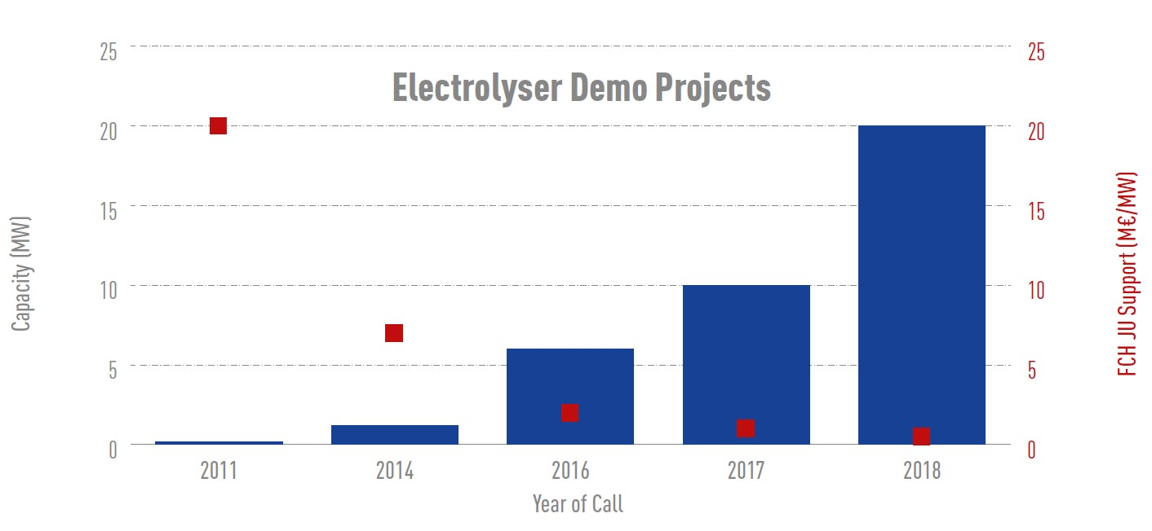

Within the **Support for Market Uptake** (cross-cutting) activities, the report highlights the progress made by projects in defining potential cost reductions, producing educational tools and developing analytical methods and test procedures.